INHERITANCE

Types of inheritance:
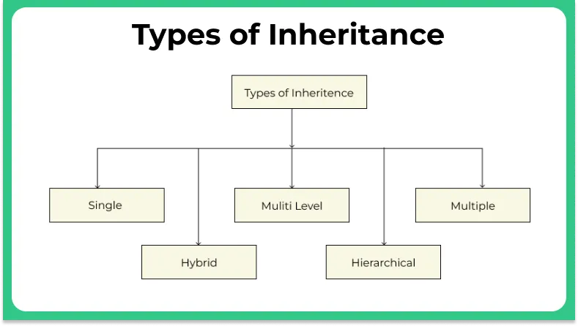

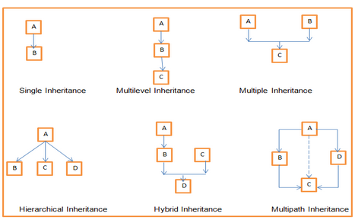

Only public and protected variables and function inherited, private method or variable never inherited from base to derived class.
Single inheritance:
//Single class inheritance
//One base class (Parent class) and one derived class (child class)

#include<iostream>
using namespace std;

//create base class
class A
{
public:
void print_A()
{
cout << endl << "Call method in class A";
}
};

//Derived class from base class
class B : public A
{
public:
//Nothing inside class B (But all functionality of class A is available)

};

int main()
{
//Create object
B test;
//call method of class A from object of class B.
test.print_A();
return 0;
}

Multiple Inheritance:
//Multiple class inheritance
//Multiple base class (Parent class) and one derived class (child class)

#include<iostream>
using namespace std;

//create base class
class A
{
public:
void print_A()
{
cout << endl << "Call method in class A";
}
};

//Other base class
class B
{
public:
void print_B()
{
cout << endl << "Call method in Class B";
}

};

//Derived class(Multiple base class)
class C : public A, public B
{
//Nothing inside C
};

int main()
{
//Create object
C test;
//call method of class A from object of class C
test.print_A();

//call method of class B from object of class C
test.print_B();

return 0;
}

OUTPUT:


Multilevel inheritance:
Mullevel inheritance means one class derived from other derived class not from direct any based class.
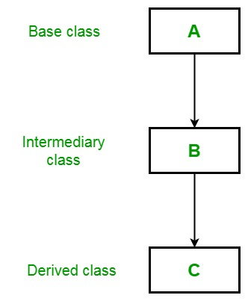

Example code:
#include<iostream>
using namespace std;

//create base class
class A
{
public:
void print_A()
{
cout << endl << "Class A method call";
}
};

//Derived class
class B : public A
{
public:
void print_B()
{
cout << endl << "Class B method call";
}

};

//Multilevel inheritance
class C : public B
{
public:
//Nothing

};

int main()
{
//Create object
C test;
//call method of class A from object of class C
test.print_A();
//call method of class B from object of class C
test.print_B();

return 0;
}
OUTPUT:
